^^ ZOOM BASICS ^^

A Zoom account isn't required to attend a meeting. Users do need a Zoom account to host a meeting ... Anyone can join a meeting using the Zoom mobile apps or desktop applications for Windows and Mac.

Getting Started with Zoom
Where do I download the latest version of Zoom?
You can download the latest version of Zoom from our Download Center. Learn more about downloading Zoom.
How to I use Zoom on my PC or Mac?
After downloading Zoom, learn how to use the Zoom Desktop Client.
Do you need an account to use Zoom?
A Zoom account is not required if you are strictly joining Zoom Meetings as a participant. If someone invites you to their meeting, you can join as a participant without creating an account. However, if the host has restricted joining meetings using authentication profiles, then the participant will need a Zoom account to access the meeting. Learn more about joining a Zoom meeting.
A Zoom account is only required if you need to create your own meetings and send invitations to participants. Having a Zoom account allows you to create your own Instant Meetings or Schedule Meetings. An account also allows you to access your personal settings, where you can update your profile or upgrade your plan at any time.
How do I signup for Zoom?
You can sign up for a free Zoom account at zoom.us/signup.
How much does Zoom cost?
A basic Zoom license is free. Learn more about available Zoom plans and pricing.

Joining a Meeting
How do I join a Zoom meeting?
You can join a meeting by clicking the meeting link or going to join.zoom.us and entering in the meeting ID. Learn more about joining a meeting.
How do I join computer/device audio?
On most devices, you can join computer/device audio by clicking Join Audio, Join with Computer Audio, or Audio to access the audio settings. Learn more about connecting your audio.
Can I Use Bluetooth Headset?
Yes, as long as the Bluetooth device is compatible with the computer or mobile device that you are using.
Do I have to have a webcam to join on Zoom?
While you are not required to have a webcam to join a Zoom Meeting or Webinar, you will not be able to transmit video of yourself. You will continue to be able to listen and speak during the meeting, share your screen, and view the webcam video of other participants.

Scheduling a Meeting
How do I schedule a meeting?
You can schedule a meeting on the web, through the Zoom Desktop client or mobile app, or through one of our many integrations. Learn more about scheduling a Zoom meeting.
How do I invite others to join my meeting?
You can invite others to join your meeting by copying the join URL or meeting invitation and sending it out via email. There are many other ways to invite others to join your meeting - learn more.

Sign in and Join
After launching Zoom, click Join a Meeting to join a meeting without signing in. If you want to log in and start or schedule your own meeting, click Sign In.
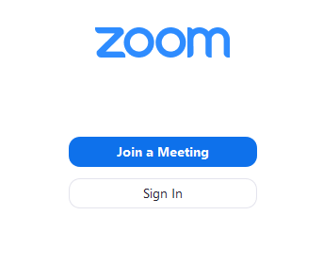
To sign in, use your Zoom, Google, or Facebook account. You can also log in using SSO. If you don't have an account, click Sign Up Free. If you have a Zoom account but cannot remember your password, click Forgot.
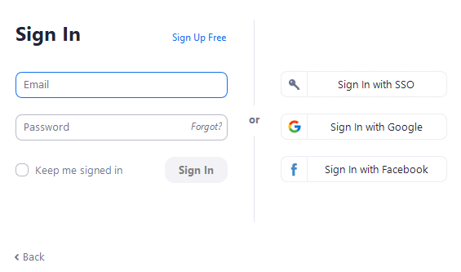

Home
After signing in, you will see the Home tab, where you can click these options:
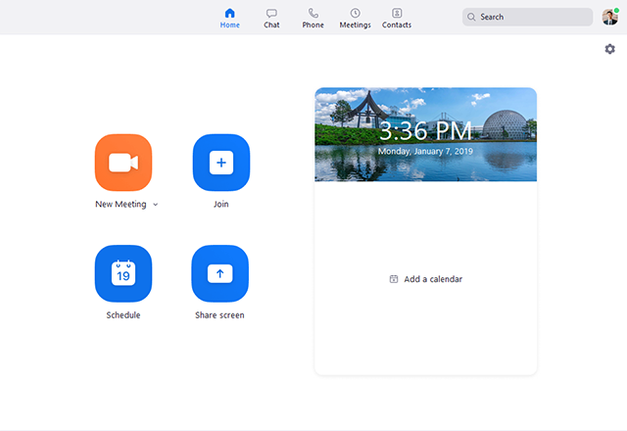
- New Meeting: Start an instant meeting. Click the downwards arrow to enable video or use your personal meeting ID (PMI) for instant meetings.
- Join: Join a meeting that is in progress.

